2021 Winter CIS200 – Programming Assignment 2

List, Operator and Friend

Professor: Jie Shen

Release date: Feb 16, 2021

Due date: Mar 04, 2021

Student name: Demetrius Johnson

Contents

**Question 1 Unsorted List (30 points)** 3

Source code (USED C++ COMPILER on Microsoft Windows 10) 3

Test data and expected results 3

TEST 1: 3

**Question 2 Operator (30 points)** 4

Source code (USED C++ COMPILER on Microsoft Windows 10) 4

Test data and expected results 4

TEST 1: 5

TEST 2: 6

TEST 3: 7

TEST 4: 8

TEST 5: 9

TEST 6: 10

# **Question 1 Unsorted List (30 points)**

## Source code (USED C++ COMPILER on Microsoft Windows 10)

See CPP and H uploads I made in canvas with this document along with the executables.

## Test data and expected results

Test Table:

|  |  |  |  |  |  |  |
| --- | --- | --- | --- | --- | --- | --- |
| Test # | Valid / Invalid Data | Description of test | Input Value | Expected Output | Actual Output | Test Pass / Fail |
| 1 | valid | Output the results from the char.dat file and the number of elements | Char.dat | See screenshot | See screenshot | pass |

### TEST 1:

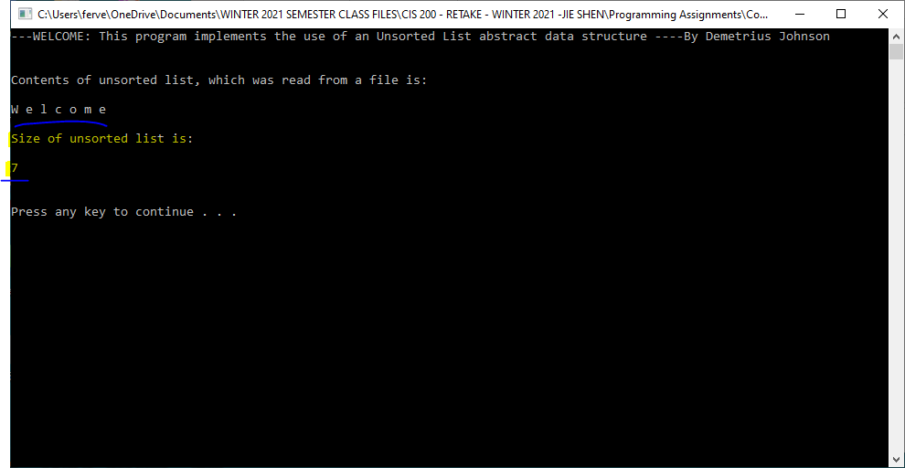

# **Question 2 Operator (30 points)**

## Source code (USED C++ COMPILER on Microsoft Windows 10)

See CPP and H uploads I made in canvas with this document along with the executables

## Test data and expected results

Test Table:

|  |  |  |  |  |  |  |
| --- | --- | --- | --- | --- | --- | --- |
| Test # | Valid / Invalid Data | Description of test | Input Value | Expected Output | Actual Output | Test Pass / Fail |
| 1 | valid | Test the copy constructer of Complex class | T(y) | See screenshot | See screenshot | pass |
| 2 | valid | Test x and y using assignment operator | Assigning x and y | See screenshot | See screenshot | pass |
| 3 | valid | Test addition and subtraction operator of Complex class | Assigning z and w | See screenshot | See screenshot | pass |
| 4 | valid | Test multiplication and division of Complex class | Assigning v and q | See screenshot | See screenshot | pass |
| 5 | valid | Test == comparison operator of Complex class | Comparing w to z | See screenshot | See screenshot | pass |
| 6 | valid | Test prefix and postfix operator++ | Assigning T to x | See screenshot | See screenshot | pass |

### TEST 1:

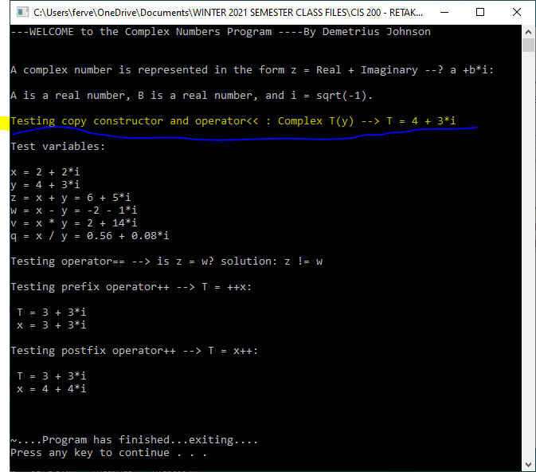

### TEST 2:

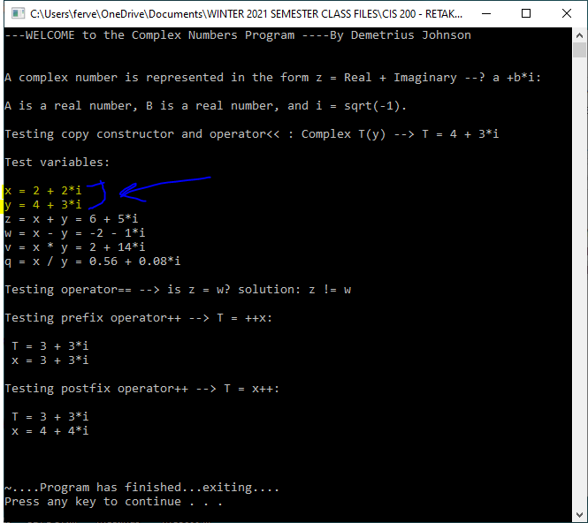

### TEST 3:

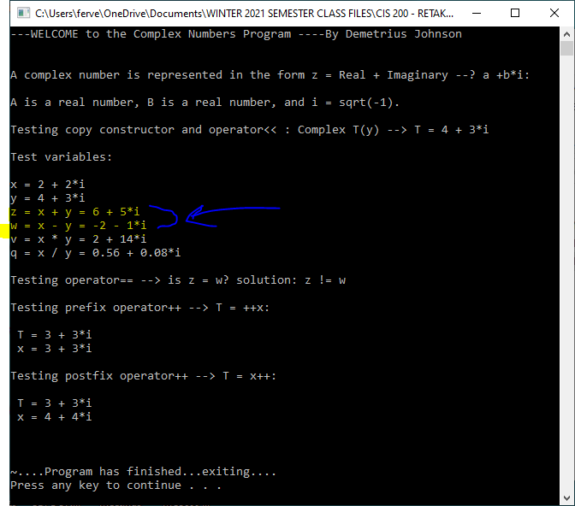

### TEST 4:

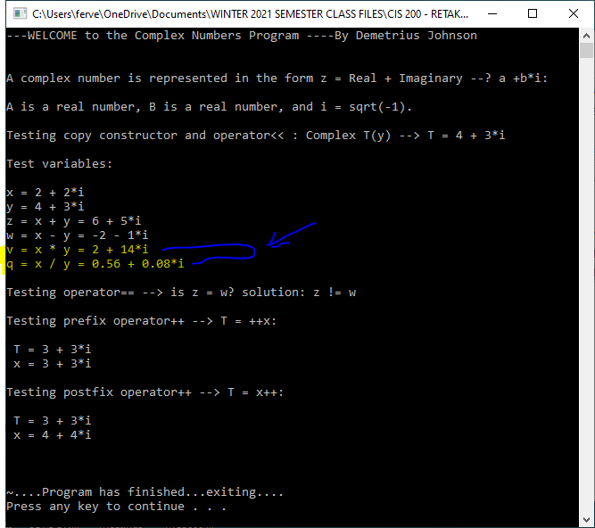

### TEST 5:

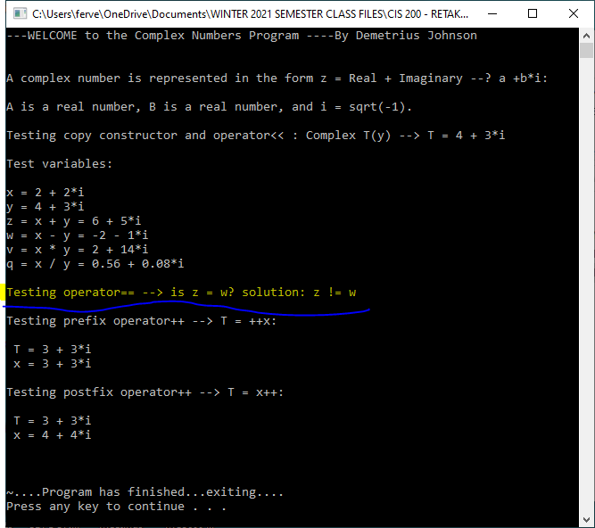

### TEST 6:

